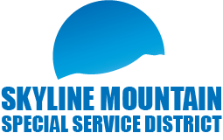

**SMSSD Public Budget Hearing and Board Meeting**

**December 19th, 2024, 6pm to 8:30pm**

**Senior Citizens Center**

**101 East 100 North Mt. Pleasant. Utah 84647**

**Public Budget Hearing**

* Final 2024 Budget
* Final 2025 Budget

**Board Meeting**

- Approval of 9-12-2024 meeting minutes

- Approval of financials

- Thad’s Peak Well Project

- Update CentraCom

- Report from SMSSD/SMR Liaison

- New / Old Business

- Open time for customers on agenda

- Adjourn

- Executive Meeting

- Adjourn

Join Zoom Meeting: <https://us06web.zoom.us/j/8018195705>

One-tap mobile: +16694449171, 8018195705# | Phone: +1 669 900 6833 / Meeting ID: 801 819 5705